Autonomous Navigation System for a Watering Robot in a Plant Nursery

Lim Jun Hao  
A0147944U

Supervisors:

A/Prof Loh Ai Poh

Dr Elliot Law

Project ID: H546010

# Table of contents

**Table of contents** **2**

**1. Overview** **4**

Description 4

Basic Task 4

Goal 4

**2. Layout of the nursery** **5**

Map layout 5

Layouts of different sections 6

**3. Concept solution** **8**

**4. Scope of work** **10**

**Understanding the task** **10**

Task and assumptions 10

Assumptions 10

Primary tasks segmented 10

Auxiliary 11

**5. Literature review** **13**

Computer vision vs LIDAR 13

Floor segmentation 14

Vision based navigation 15

Computer vision based positioning system 15

**6. Selection of hardware components** **16**

6.1 Selection of hardware (for development) **16**

Robot (Chassis w/ motor) 16

iRobot Create® 2 16

TurtleBot3 16

Computation 16

Raspberry Pi 3 Model B+ 16

Nvidia Jetson 16

Laptop with on-board GPU 16

Full-fledged computer with GPU 17

Supplementary parts 17

360 Laser Distance Sensor LDS-01 (LIDAR) 17

Camera(s) 17

6.2 Selection of hardware (for production) **17**

**7. Implementation** **18**

Controlling the iRobot Create® 2 18

Floor segmentation 18

Preliminary testing at hostel corridor 18

**8. Future work** **20**

Tasks 20

# 1. Overview

## Description

Changi Airport Group’s (CAG) Nursery houses a vast number of plants to supply fresh decorative plants for the Airport. The plants needs to be watered and this is a laborous task if done manually, taking up a significant amount of time which can be better spent on non-automated specialized tasks.

It currently employs an automated irrigation system which uses overhead sprinklers that turns on at scheduled regular timings. However, this system faces a limitation with larger plants where the water is unable to reach the roots and water is wasted. This results in the caretakers having to manually water these plants, defeating the purpose of the irrigation system.

CAG’s management team feels that this is inefficient and are looking for other automated solutions that will perform more efficiently, namely robotics as it can provide a more targeted watering as with a person.

## Basic Task

Basic requirements of the navigation system:

* Navigate safely around the nursery
* Stop at specific positions to water the plants
* Return to charging station (after completion of scheduled job or low battery)

The use case imposes limitations as well as fulfills some assumptions which differentiates this from the more common autonomous driving vehicles on roads.

## Goal

To create a navigation system for a watering robot in a nursery, essentially designing the navigation system of an Autonomous Vehicle. This relieves the team of the laborious and repetitive task of watering the plants regularly.

The problem could easily be solved using a basic line-following navigation system, with different colors signaling when to stop etc. However, this assumes an ideal situation where no objects or people will obstruct the robot. Also, having lines painted/drawn on the floors of the nursery may be unsightly. Hence, the intent is to develop a system which is ‘smart’ where it can actively detect and react automatically and efficiently to non-ideal scenarios.

On the flip side, electing to use a combination of various sensors simultaneously, as with autonomous cars, will be overkill for the task at hand. It will also be extremely computationally intensive to fully process all the data and costly to acquire all the necessary hardware.

As such this project is aimed at developing a solution that is suitable for the problem at hand that is effective with minimal compromises while minimizing the required hardware and complexity.

# 2. Layout of the nursery

## Map layout

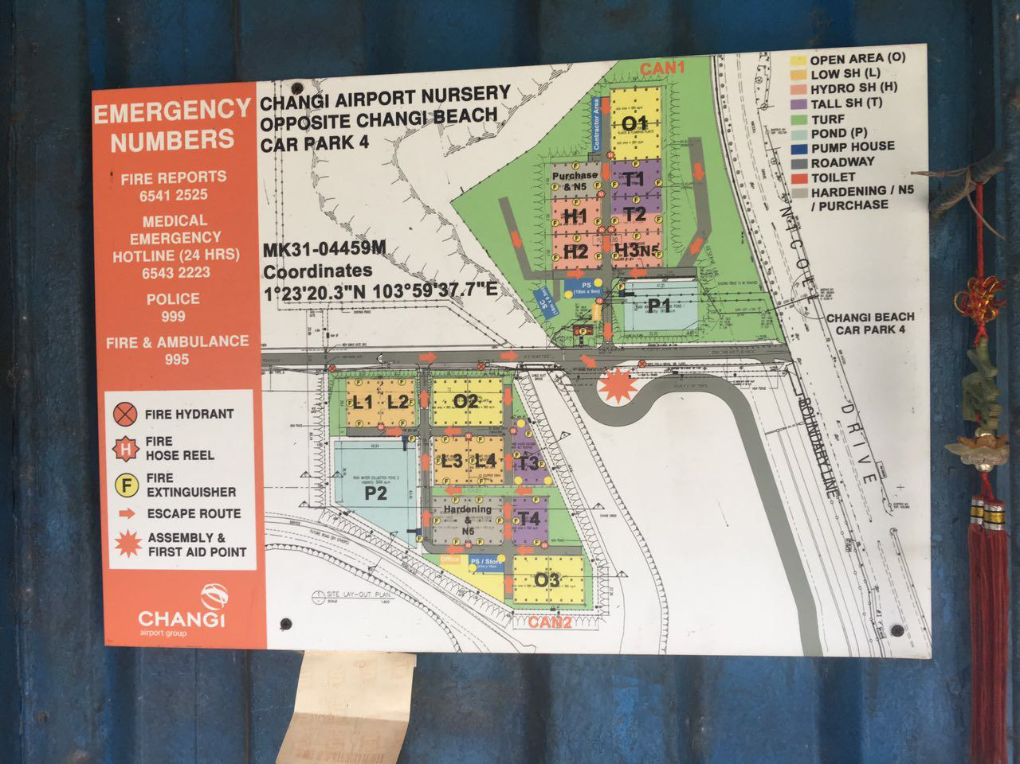

Figure 1: Map of nursery

The nursery is quite large and hence it is not possible to consider the whole nursery for development of the system. Furthermore, certain sections may be unsuitable for a wheel-based robot to navigate through.

## Layouts of different sections

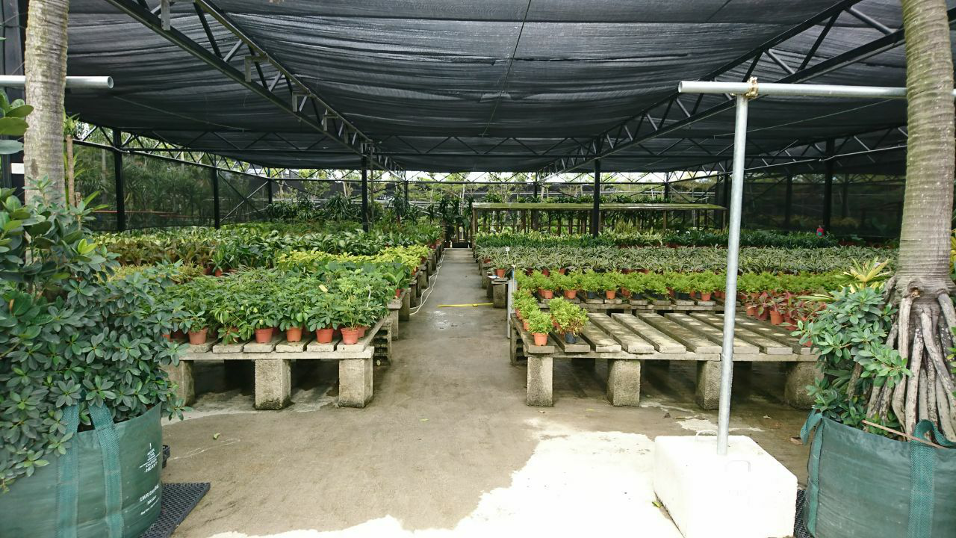

Figure 2: Photo of a neat section in the nursery

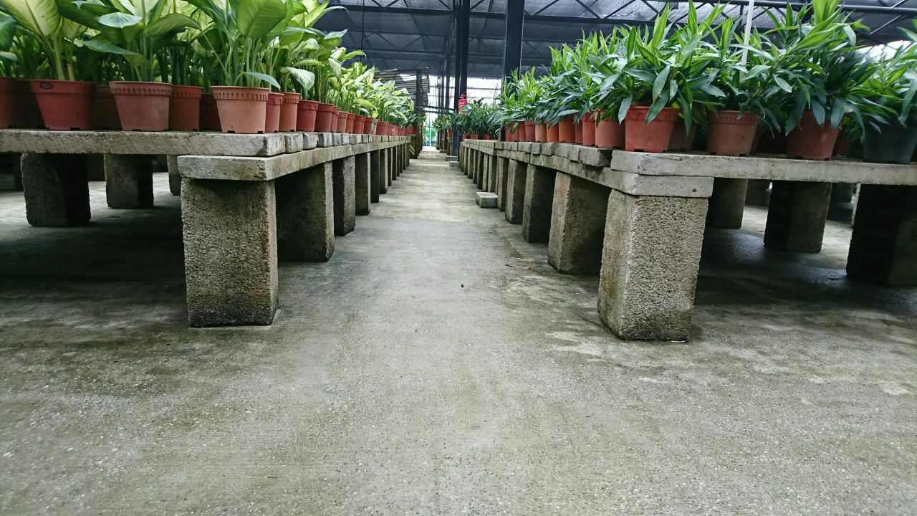

Figure 3: Another photo of a neat section in the nursery

Some areas are neat and tidy with clear straight paths and junctions. This is the ideal situation as the robot should face minimal difficulties in these areas. It should be noted that the paths have no obvious ‘lines’ or walls but are instead lined with the legs of the plant benches. This unique feature may be capitalized on to aid in the navigation of the robot.

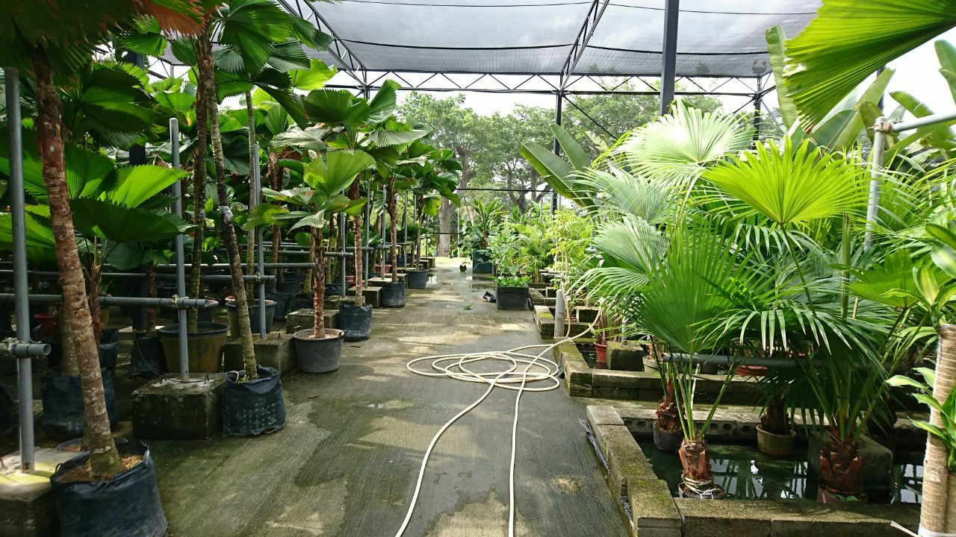

Figure 4: Very different layout, no benches, hoses on floor

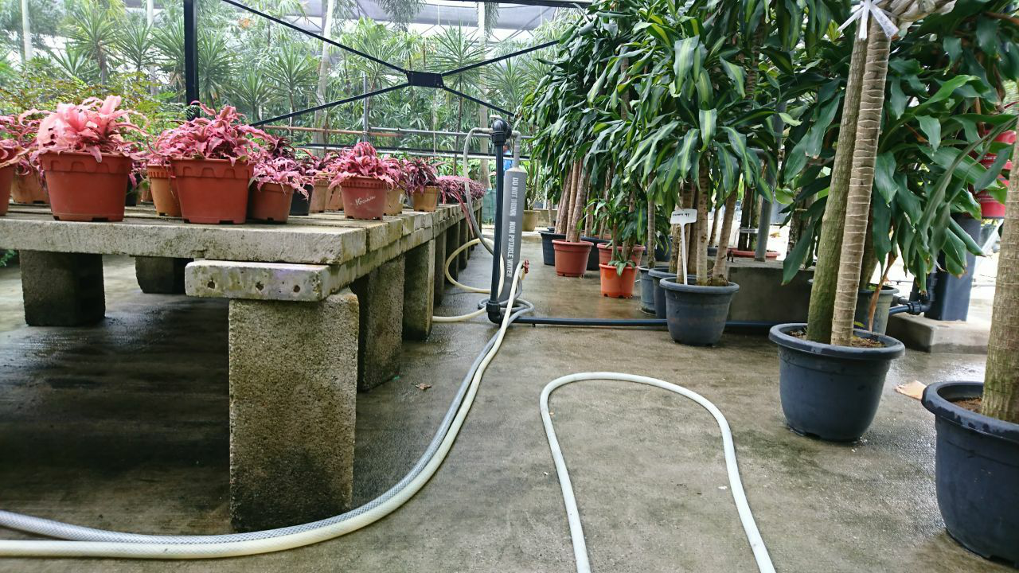

Figure 5: Hoses on floor and permanent fixtures blocking paths

However, other areas have obstacles as well as hoses lying on the floor as seen in figures 4 & 5. These needs to be detected and avoided by the robot to prevent damage to the property. Ideally, temporary obstacles such as hoses should be removed and kept to a minimum as it will limit the areas the robot can reach. On the other hand, permanent fixtures such as the pipe in figure 5 can be recorded as virtual walls or used as landmarks for localization of the robot.

# 3. Concept solution

This project serves to complement another on-going project where the functional robot has been built by the project’s team. It is currently using line-following as a means of navigation in its area of operations with QR codes to scan to inform the robot when to perform a certain action.

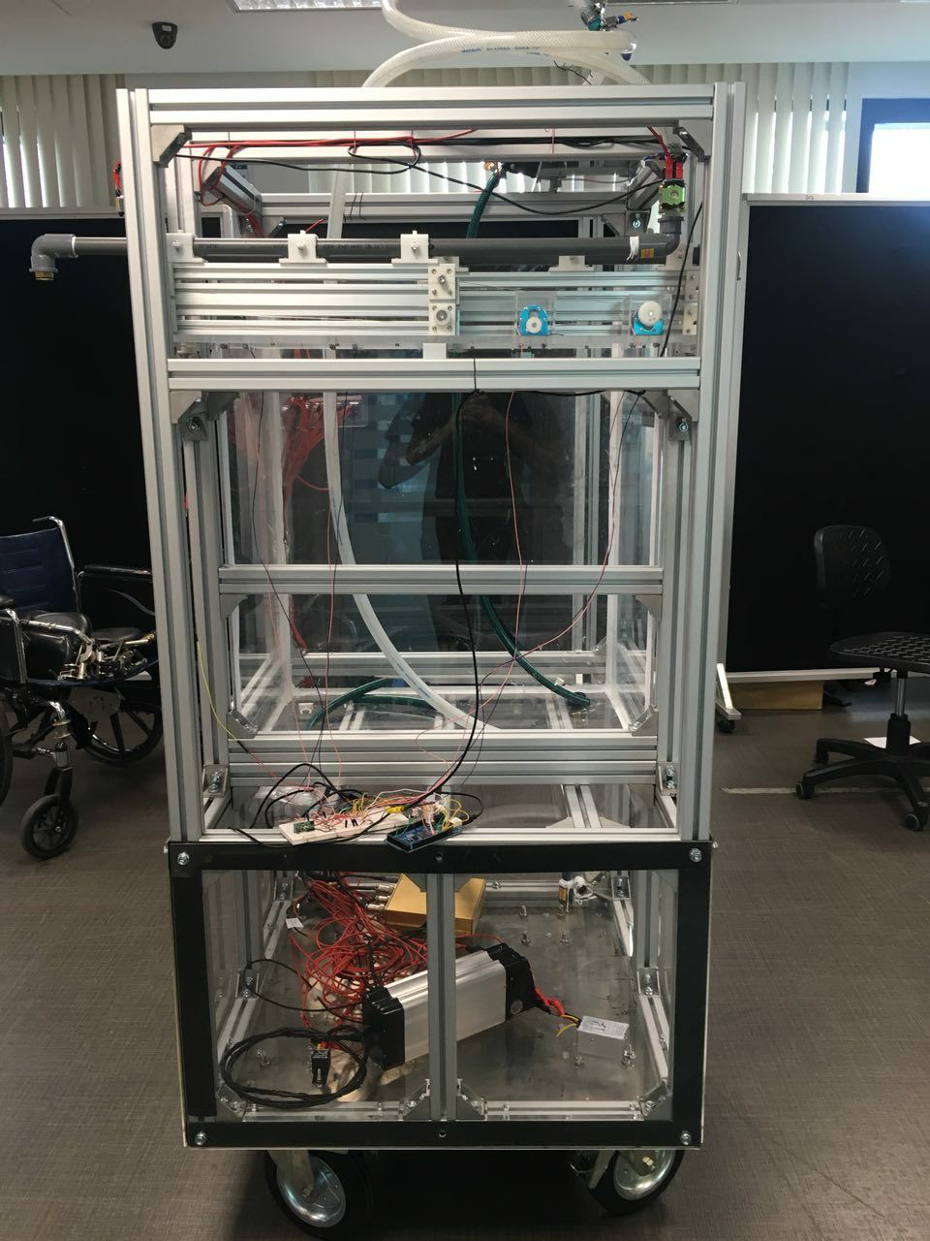

Figure 6: Original robot

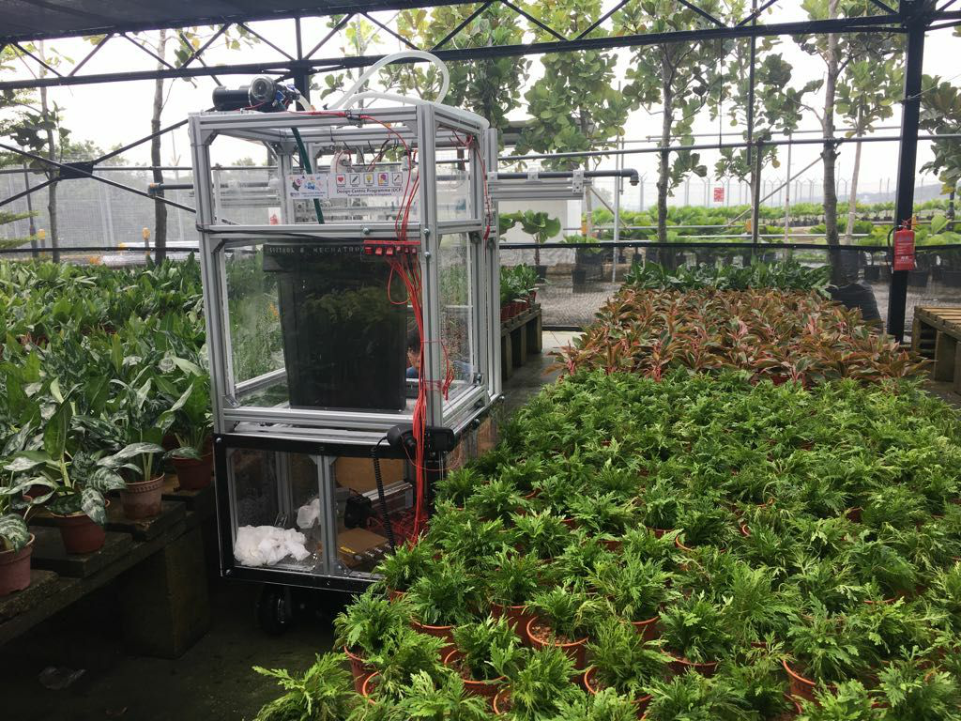

Figure 7: Robot in nursery

The robot is large but is comfortably within the constraints of the path width. Owing to the size, the robot is unable to make a 360 degree turn along a path and it has to move in reverse instead.

# 4. Scope of work

## Task and assumptions

Fuller requirements of the navigation system

* Navigate **safely** around the nursery
  + Comprehend a predefined map
  + Determine its current position on the predefined map
  + Move robot along the paths of the nursery
  + Detecting and avoiding obstacles
* Stop at specific positions to water the plants
  + Detect if there are significant changes to an area
* Return to charging station (after completion of scheduled job/low battery/low water level)
* User interface for updating data
  + Assigning blocked/restricted areas
  + Updating target areas

### Assumptions

* The layout (paths and possible locations of plants) of the nursery will not change
  + This allows a predefined map to be used and thus, do not require the complex simultaneous localization and mapping (SLAM)

## Primary tasks segmented

1. Map Understanding  
   Description:  
   - Ability to figure out path to reach all necessary watering spots and return to base with the shortest path  
   Type: Software  
   Solution 1: Travelling salesman problem  
   Solution 2: Shortest path problem
2. Path following  
   Description:  
   - Ability to commandeer machine to smoothly (following path without zig-zagging, smooth turns)  
   Type: Hardware + Software  
   Solution 1: Computer vision (Floor segmentation)  
   H/W Requirements: Front facing camera  
   Solution 2: LIDAR
3. Localization  
   Description:  
   - Ability to find its current position in map accurately  
   Type: Hardware + Software  
   Solution 1: Computer vision (Scene classifier)  
   H/W Requirements: Cameras  
   Solution 2: Computer vision (Floor segmentation)  
   H/W Requirements: Same as path following (floor segmentation)  
   Issues: May not be accurate i.e. in long stretch of a straight and clean path  
   Solution 3: LIDAR  
   Issues: Same with solution 2, may not be accurate i.e. in long stretch of a straight and clean path
4. Obstacle avoidance  
   Description:  
   - Ability to detect obstacles on path  
   - Check if obstacle detected is a stationary object (permanent) or if its a person (temporary, wait for set duration before moving off)  
   Type: Hardware + Software  
   Solution 1: Computer vision (Floor segmentation, person detector)  
   H/W Requirements: Front facing camera  
   Solution 2: LIDAR
5. Detecting watering spots  
   Description:  
   - Ability to detect when it is in position to water plants  
   Type: Hardware + Software  
   Solution 1: Accurate localization  
   If localization solution is accurate enough, it will be used to determine if it has reached a watering spot  
   Solution 2: QR code or some form of distinct identifier for robot to visually detect  
   H/W Requirements: Camera(s)

## Auxiliary

1. Detecting if plants are removed

Description:  
- Ability to detect if plants are removed from an area  
Type: Hardware + Software  
Solution: Image classification (scene/object detector)  
When the watering spot is reached, an image of the target area is processed to determine if the plants in that area is removed to avoid watering empty spots.  
H/W Requirements: Camera(s)

1. Battery level status  
   Description:  
   - Ability to poll battery level and initiate a return-to-base with the shortest path if battery level is running low
2. Water level status  
   Description:  
   - Ability to poll water level and initiate a return-to-base with the shortest path if water level is running low

# 5. Literature review

## Computer vision vs LIDAR

Modern advanced autonomous navigation employs both simultaneously to complement each other’s data in order to achieve an accurate representation of the surroundings digitally. However, our use case isn’t as demanding as the robot does not move at high speeds which significantly reduces the risks and required resolution of data. Hence simply either one of the two should provide sufficient data to accomplish this task.

**The Benefits of Vision Guided Robot Systems, 2017**

<https://www.visiononline.org/blog-article.cfm/The-Benefits-of-Vision-Guided-Robot-Systems/55>

Vision-Guided Robots Are More Precise and Productive

Multiple New Factors are Driving Machine Vision's Rapid Growth

**Robot Navigation - "Where am I going and how do I get there" An Overview of Local/Personal Robot Navigation - Oliver Henlich, 20 May 1997**

<https://www.doc.ic.ac.uk/~nd/surprise_97/journal/vol1/oh/>

Robot guidance techniques generally consisted essentially of following buried cables or painted lines. These techniques are very reliable and fairly easy to implement but they heavily constrain the motion of the robot.

**A Survey of Deep Learning Techniques for Mobile Robot Applications, 2015**

<https://arxiv.org/pdf/1803.07608.pdf>

**Mobile Robot Navigation - Andersen, Jens Christian, 2007**

<http://orbit.dtu.dk/files/4724729/oersted-dtu2868.pdf>

“The road classification is based on laser scanner measurements and supported at longer ranges by vision. The road classification is sufficiently sensitive to separate the road from flat roadsides, and to distinguish asphalt roads from gravelled roads. The vision-based road detection uses a combination of chromaticity and edge detection to outline the traversable part of the road based on a laser scanner classified sample area.

The perception of these two sensors are utilised by a path planner to allow a number of drive modes, and especially the ability to follow road edges are investigated.

The navigation mission is controlled by a script language. The navigation script controls route sequencing, junction detection, junction crossing calculations and drive mode selection.”

**Mobile Robot Navigation With Low-Cost Sensors, 2009**

<https://cloudfront.escholarship.org/dist/prd/content/qt1g77q1fx/qt1g77q1fx.pdf?t=mhwyao>

**Mobile Robot Navigation and Obstacle Avoidance Techniques: A Review, 2017**

<https://medcraveonline.com/IRATJ/IRATJ-02-00023.pdf>

In-depth analysis of various visual based algorithms

**MIT's blind Cheetah 3 robot can navigate without sensors or cameras, 2018**

<https://www.dezeen.com/2018/07/17/institute-of-technology-mit-blind-cheetah-3-robot-massachusetts-technology/>

"blind locomotion", meaning it "feels" its path through an environment — a process the team likens to a person making their way across a pitch-black room.

**Why people use camera instead of laser sensor for robot navigation?**

<https://robotics.stackexchange.com/questions/10761/why-people-use-camera-instead-of-laser-sensor-for-robot-navigation>

“A 3D laser range finder or LIDAR such as the one on the Google Car is far more expensive than a camera. The other reason is that while in case of a LIDAR the distance of every pixel is available, the generated data to be processed is enormous. You have to transfer and process data faster which comes out again as rising cost. Finally cameras usually have a longer lifetime, so there is less maintenance required.

With relatively cheap cameras and computer vision, pretty good results can be achieved.”

**OpenSimpleLidar**

<https://github.com/iliasam/OpenSimpleLidar>

Video: <https://www.youtube.com/watch?v=YHt_NTktmlA>

Great showcase of a robot navigation using LIDAR and the project details hardware requirements and implementation structure which provides a great guide to embark on developing and integrating with LIDAR systems.

## Floor segmentation

**Floor Segmentation - IIIT-Hyderabad, 2013**

Video: <https://youtu.be/SMvHyMXiP1k>

Shows how floor segmentation can detect and avoid obstacles.

**Floor Segmentation, 2015**

Video: <https://youtu.be/3M78qyrev1k>

Visually similar to what I have in mind where junctions in the path is very obvious for indoor applications.

**floor segmentation, 2012**

Video: <https://youtu.be/yAsvA2X3WKA>

Shows how floor segmentation can detect and avoid obstacles.

## Vision based navigation

**Autonomous Indoor Robot Navigation Using Sketched Maps and Routes, 2015**

<http://ais.informatik.uni-freiburg.de/publications/papers/boniardi16icra.pdf>

Video: <https://youtu.be/Pg15dr6_7GM>

Uses a given map and compares it against its surroundings to try to derive its location thus able to follow a given path. This is an impressive demonstration and for our project’s use case, this can be further expanded by giving the program the ability to draw its own path to meet certain goals.

**Vision based Navigation and Localization, 2008**

Video: <https://youtu.be/nb0VpSYtJ_Y>

Uses features on walls/floors such as corners, wall design and handrails to draw lines which aids in directing the robot to face forward along the path

## Computer vision based positioning system

**Indoor Navigation System by computer vision, 2013**

<https://www.sciencedirect.com/science/article/pii/S1877050914000076>

<https://link.springer.com/article/10.1007/s10209-013-0338-8>

Video: <https://youtu.be/WoBcsnEGiB8>

While the video demonstration isn’t impressive, it does a good job of showcasing the ability to detect features/objects in scenes to determine location in an indoor environment.

**Demo - Indoor Positioning System Based on Computer Vision, 2013**

Video: <https://youtu.be/vuRmkj6jPr4>

More accurate location.

# 6. Selection of hardware components

## 6.1 Selection of hardware (for development)

## Robot (Chassis w/ motor)

### iRobot Create® 2

<https://www.irobot.com/about-irobot/stem/create-2>

A relatively barebones robot with little to no useful sensors.

Maximum payload: 9kg

### TurtleBot3

<http://emanual.robotis.com/docs/en/platform/turtlebot3/specifications/>

A complete robot intended for development with useful sensors such as a LIDAR, camera, Gyroscope, Accelerometer, Magnetometer etc.

Maximum payload: 15/30kg (depending on model)

**Selection: iRobot Create® 2**

It is available in the school from which I can loan from. While the features of the TurtleBot3 models are perfect, they are not all necessary and can easily be bought seperately and added on to the system. The TurtleBot3 models are also very costly.

Sourcing: Loan from school

Able to withstand 9kg of payload <https://robotics.stackexchange.com/questions/5132/what-is-the-maximum-payload-weight-for-create-2-can-i-use-old-create-accessories>

## Computation

### Raspberry Pi 3 Model B+

<https://www.raspberrypi.org/products/raspberry-pi-3-model-b-plus/>

### Nvidia Jetson

<https://www.nvidia.com/en-us/autonomous-machines/embedded-systems/>

### Laptop with on-board GPU

The options for the robots listed above are able to easily carry the weight of a laptop (often under 3kg)

### Full-fledged computer with GPU

Data can be forwarded to a nearby computer via wireless communications (i.e. bluetooth serial adapter, or through a Raspberry Pi) for processing.

**Selection: Laptop with on-board GPU**

Given that the use case does not demand high speed nor extremely precise movements, it is not required to process many frames per second (fps). Thus a lower end option for computation should suffice. For development, I will be using my laptop that has a GPU in it to test the approaches as it should easily meet the computational demands.

Furthermore, it can rest on the robot itself, eliminating the need for wireless communications which may add a layer of latency or face limited bandwidth.

Sourcing: Provided by myself

Laptop includes a Nvidia 970M GPU which is sufficient for the scope of this project in real-time.

## Supplementary parts

### 360 Laser Distance Sensor LDS-01 (LIDAR)

The LIDAR sensor used on the TurtleBot3.

Sourcing: Purchase online <http://www.robotis.us/360-laser-distance-sensor-lds-01-lidar/> US$179.90

Comes with a USB interface which can be easily interfaced with the laptop.

Sampling rate: 1.8kHz

Power: via USB

Weight: Under 125g

### Camera(s)

Ideally with optical stabilization

Raspberry Pi Camera Module V2 - <https://www.raspberrypi.org/products/camera-module-v2/>

USB Webcam - <https://www.logitech.com/en-sg/video/webcams>

## 6.2 Selection of hardware (for production)

-Incomplete-

# 7. Implementation

-Incomplete-

## Controlling the iRobot Create® 2

Python based, using serial connection via USB to interface with the robot.

## Floor segmentation

### Preliminary testing at hostel corridor

### 

Figures 8a,8b: Clear detection of obstacles (slippers)

### 

Figures 9a,9b: Does not perform as well in low-light for obstacle detection

### 

Figures 10a,10b: Junctions are very distinct

# 8. Future work

Most of the research legwork have been done during the first half of this project and the actual implementation of the proposed solutions will be done in the later half.

## Tasks

1. Interface with the iRobot Create® 2 and have full control over it via python programming (already in-progress)
2. Integrate floor segmentation with steering of robot along corridors
3. Research on and develop mapping system
4. Research on and develop localization system
5. Integrate all systems together as a fully functional system
6. Integrate LIDAR with steering of robot along corridors
7. Integrate all systems (using LIDAR instead of cameras) together as a fully functional system
8. Compare the two implementations
9. Test on actual location

On the next page is a Gantt chart with expanded tasks and the estimated timeline. Most of the tasks have at least one day of buffer on top of the weekends which are not considered. The tasks may face a slowdown during late September due to Mid-Terms and hence there is a week (21-25 October) left free to finish the project while leaving time to polish up the final report and prepare the presentation materials.

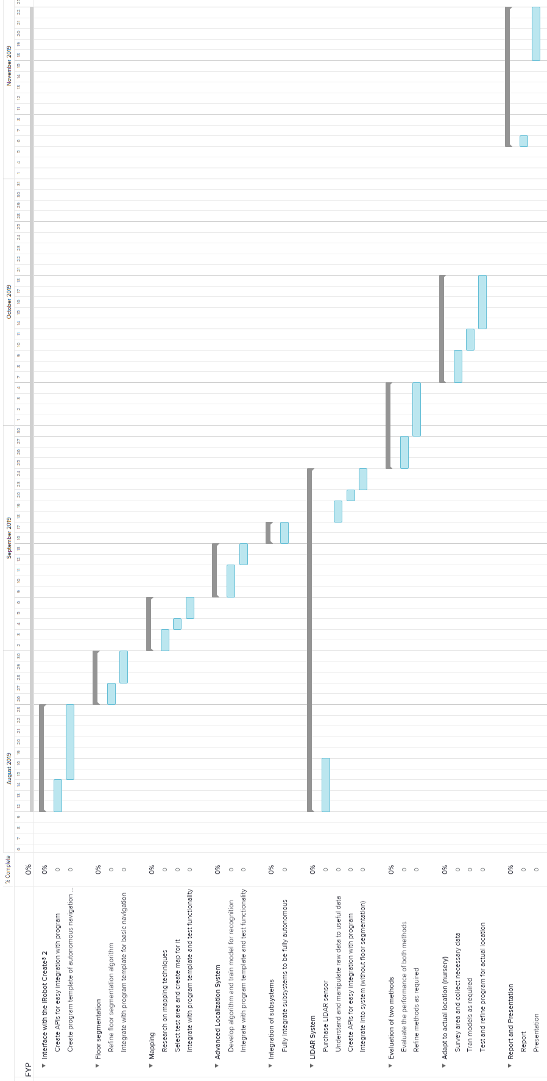

Figure 11: Gantt chart of tasks